Part B – Database Planning Patrick Mockler

Stephen Leblanc

Database Diagram

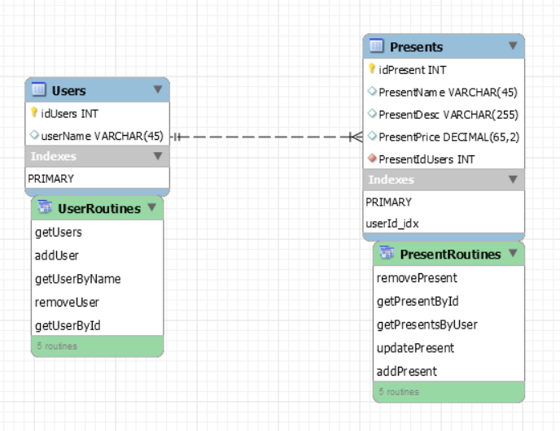

Stored Procedure Dictionary

* **getPresentsByUser**: Takes a User ID and returns a list of Presents associated with the user.
* **getPresentById**: Takes a Present ID and returns the associated Present.
* **getUsers**: Returns a list of all Users.
* **getUserById**: Takes a User ID and returns the associated User.
* **getUserByName**: Takes a Username and returns the associated User.
* **addPresent**: Takes in Present values and creates a new Present, returning the new ID.
* **removePresent**: Takes in a Present ID and deletes it from the list of Presents, returning whether or not the operation was successful.
* **updatePresent**: Takes in Present information and a Present ID and updates the specified present information, returning whether or not the operation was successful.
* **addUser**: Takes in User information and creates a new User, returning the new ID.
* **removeUser**: Takes in a User ID and removes it and its associated presents from the database, returning whether or not the operation was successful.